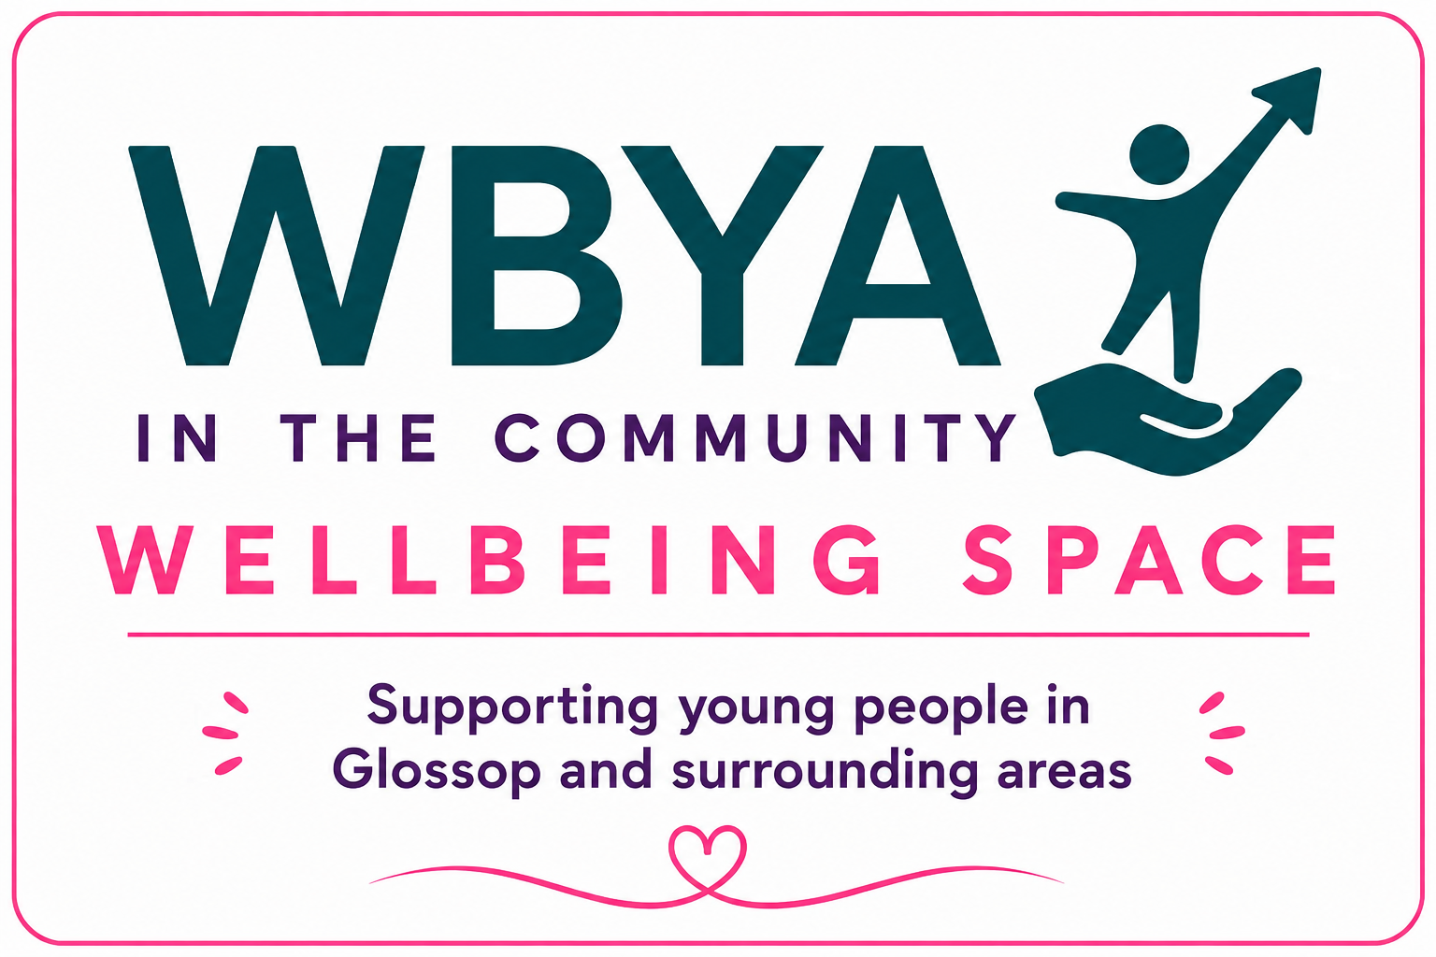

Wellbeing Space Referral Form
Email completed referrals to: wellbeingspace@wbyainthecommunity.co.uk
PLEASE NOTE
WBYA In the Community provides early intervention wellbeing support and is not a crisis or emergency mental health service. If a young person is at immediate risk of harm, please contact the appropriate emergency services or safeguarding agencies before submitting this referral.

1. Referral Details
Referral Type - Self-Referral, Parent/Carer, Professional
Date of Referral
Referrer's Name
Organisation (if applicable)
Job Title
Telephone
Email

2. Young Person Details
Young Person's Name
Preferred Name
Date of Birth
Age
Address
Postcode
School/College (if applicable)
Parent/Carer Name
Relationship to Young Person
Telephone
Email

3. Medical Information
Medical Conditions
Medication
Allergies
Additional Needs / Disabilities

4. Young Person's Voice
☐ Young person is aware of this referral ☐ Young person is NOT aware
☐ Young person agrees to this referral ☐ Young person does not agree ☐ Unsure
☐ Parent/Carer aware of referral ☐ Parent/Carer not aware ☐ N/A
How does the young person feel about attending? ☐ Looking forward ☐ Happy ☐ Unsure ☐ Reluctant
What does the young person hope to gain from attending?
____________________________________________________________
____________________________________________________________
____________________________________________________________

5. Reason for Referral (Tick all that apply)
☐ Anxiety ☐ Low Mood ☐ Emotional Wellbeing ☐ Low Confidence
☐ Social Isolation ☐ Family Difficulties ☐ Friendship Difficulties
☐ Emotional Regulation ☐ ADHD/Autism ☐ Waiting for CAMHS/Mental Health Support
☐ Bereavement ☐ Bullying ☐ School Concerns ☐ Other __________________
Please tell us about the young person's current needs and the reason for this referral:
____________________________________________________________
____________________________________________________________
____________________________________________________________
What support do you feel the young person would benefit from?
____________________________________________________________
____________________________________________________________
____________________________________________________________
What are the young person's strengths, interests and hobbies?
____________________________________________________________
____________________________________________________________
____________________________________________________________
Current professionals involved:
____________________________________________________________
____________________________________________________________
____________________________________________________________
Are there any safeguarding concerns or risks WBYA should be aware of?
____________________________________________________________
____________________________________________________________
____________________________________________________________
Anything else you would like us to know?
____________________________________________________________
____________________________________________________________
____________________________________________________________

6. Declaration (Complete ONE section only)
Professional Referral
☐ I have discussed this referral with the young person where appropriate.
☐ I have informed the parent/carer where appropriate.
Professional Name
Signature
Date
Parent/Carer Referral
☐ I confirm the information provided is accurate.
☐ I consent to WBYA contacting me regarding this referral.
Parent/Carer Name
Signature
Date
Self-Referral
☐ I would like support from WBYA.
☐ I understand WBYA will contact me and, where appropriate, my parent/carer.
Young Person's Name
Signature
Date

7. WBYA Office Use Only
Referral Received
Reviewed by Director / DSL
Outcome
Registration Pack Sent
Registration Pack Returned
Welcome Meeting Booked
First Session Date
Allocated Staff Member
Notes

